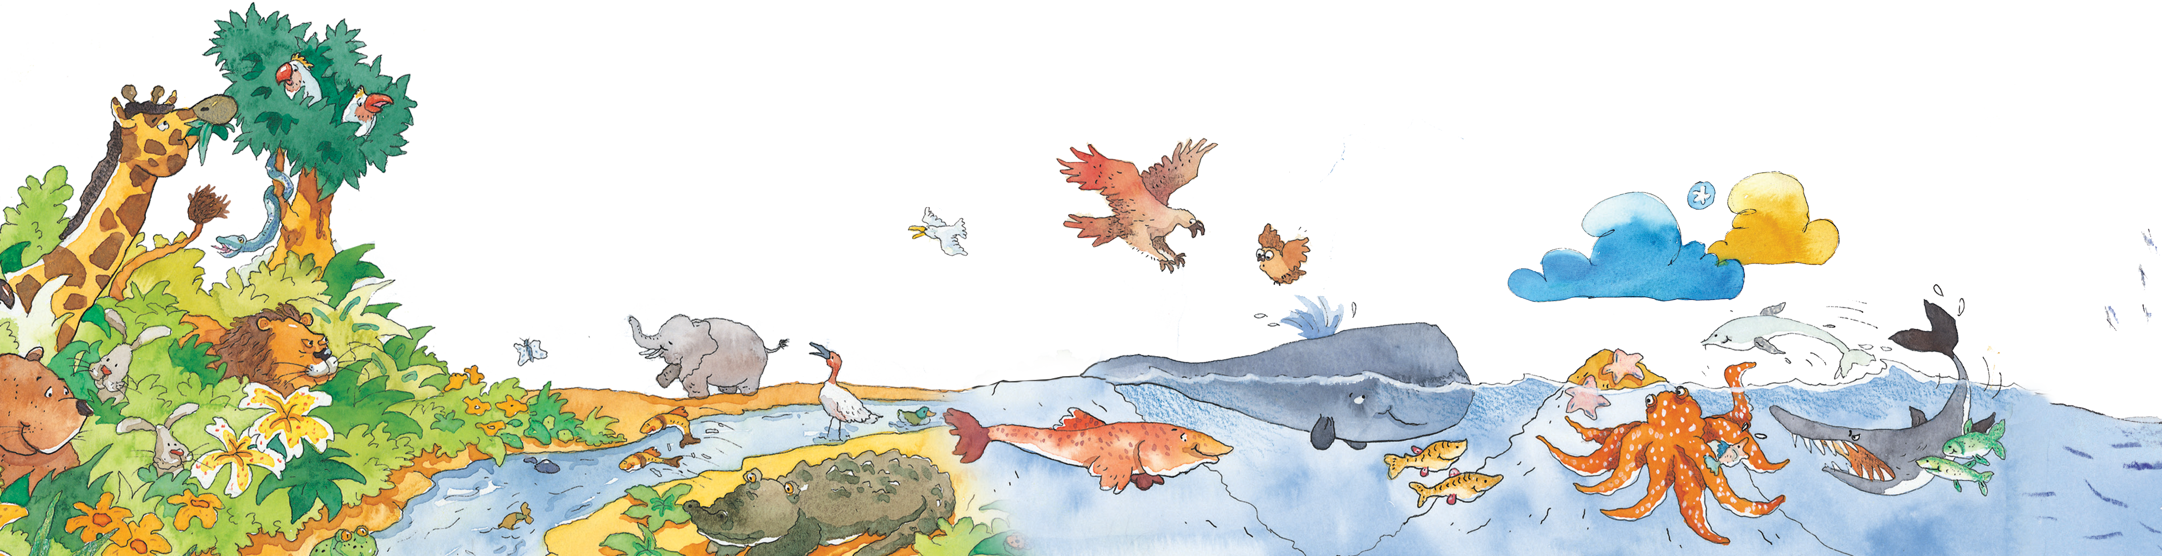

When fle decrees a thing, fle need only say, ‘Be!’ and it is.

i

g

Ya Sin 36:82

nce upon a time, there was only darkness. There was no sun and there was no sky. Stars didn’t

O

shimmer. Moons didn’t glitter. Everything was black.

Suddenly, Allah spoke aloud. “Be!” He said. Then our world was made.

The land was spread across space. Oceans rushed through the earth. Allah put mountains in their places. Soon He scattered stars in our skies so they twinkled in dark nights.

4